# Exercises: CSS Selectors and Rules

## The Future of Cars

You are given the HTMLfor the following Web page. Write the missing CSS: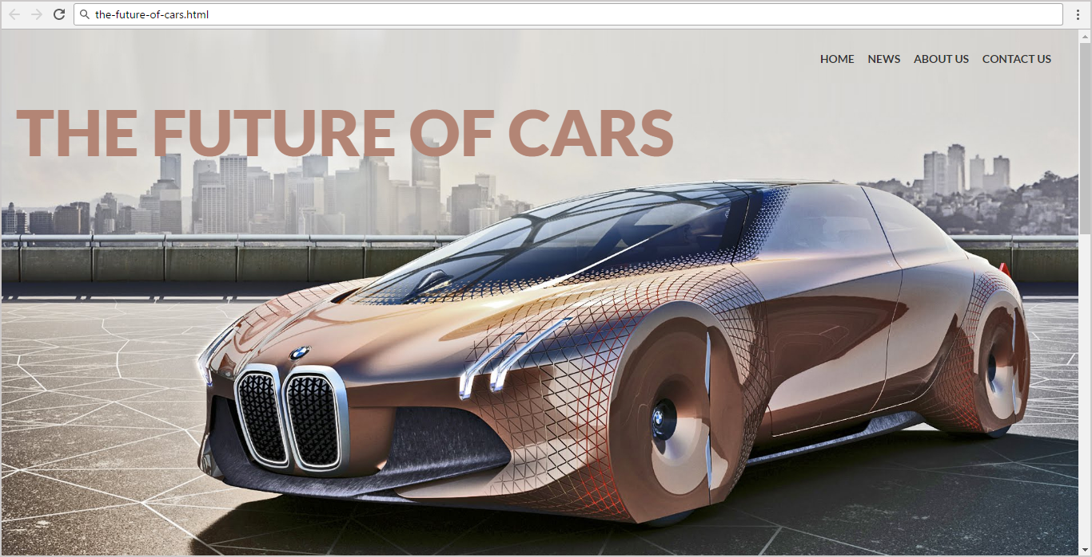

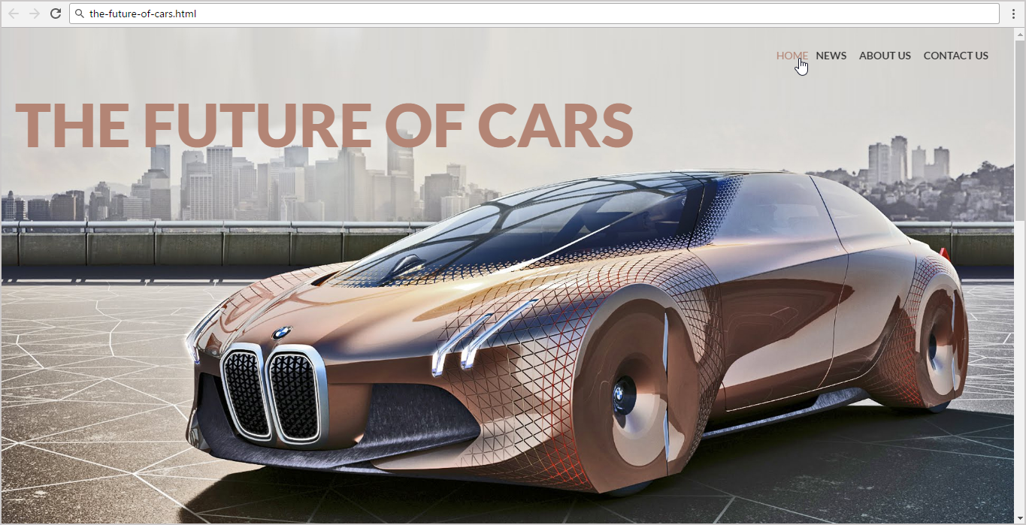

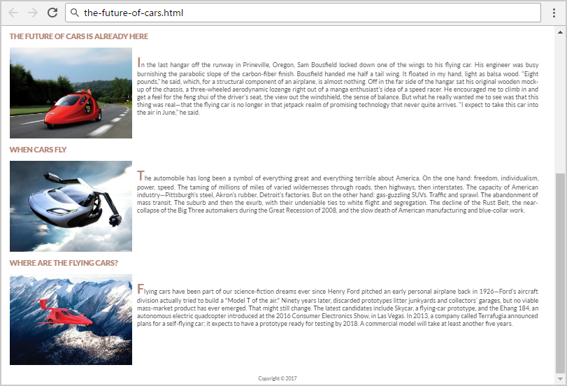

* Use the HTML file given in the resources: "**the-future-of-cars.html**".
  + You are **NOT** allowed to change the HTML code.
* Create the CSS file and write the missing styles: "**the-future-of-cars.css**".

### Steps to Follow

Start with the **site header**:

* Copy the CSS @import for the ‘**Lato**’ **font** from Google Fonts: <https://fonts.google.com/selection?selection.family=Lato>
* <body>
  + Text font: 'Lato', sans-serif;
  + Text size: 14px;
  + Text color: #333333;
  + Margin: 0px;
  + Padding: 0px;
* Site header
  + Background: url("*…<locate the background image>…*") no-repeat center;
  + Background Size: cover;
  + Height: 700px;
* Style the heading: <h1> in the site header
  + Text size: 80px;
  + Font-family: 'Lato', sans-serif;
  + Margin: 0;
  + Padding: 80px 0 0 20px;
  + Text Weight: 900;
  + Text Color: #b38575;
  + Display the text in UPPERCASE

Test the site header in the browser:

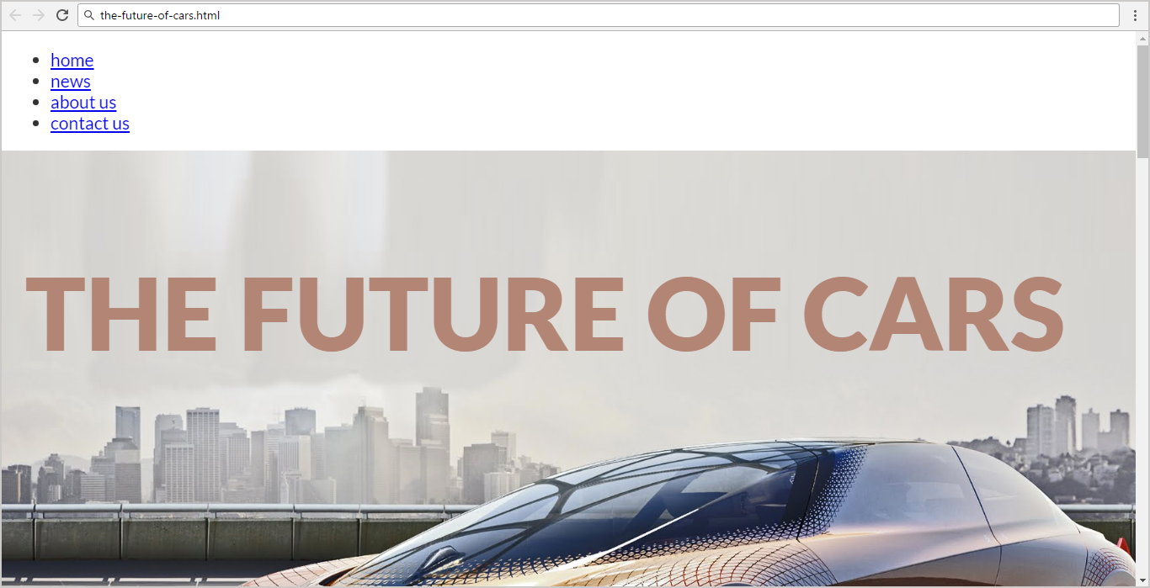

Now style the top navigation:

* <nav>
  + Margin: 20px;
  + Float: right;
* **Unordered list in the navigation**
  + Margin: 0;
  + Padding: 7px;
  + Heigth: 20px;
  + Line Heigth: 20px;
* **List items in the navigation**
  + Display as inline blocks
* **Hyperlinks in the navigation**
  + Make them UPPERCASE
* **Hyperlinks**: a, a:link, active, visited
  + Text Color: #333;
  + Padding: 5px 7px 10px 7px;
  + Text size: **1em;**
  + Font Weight: bold;
  + Remove text undeline
* **Hyperlinks with mouse over it**
  + Text Color: #b38575;

Test the site navigation in the browser:

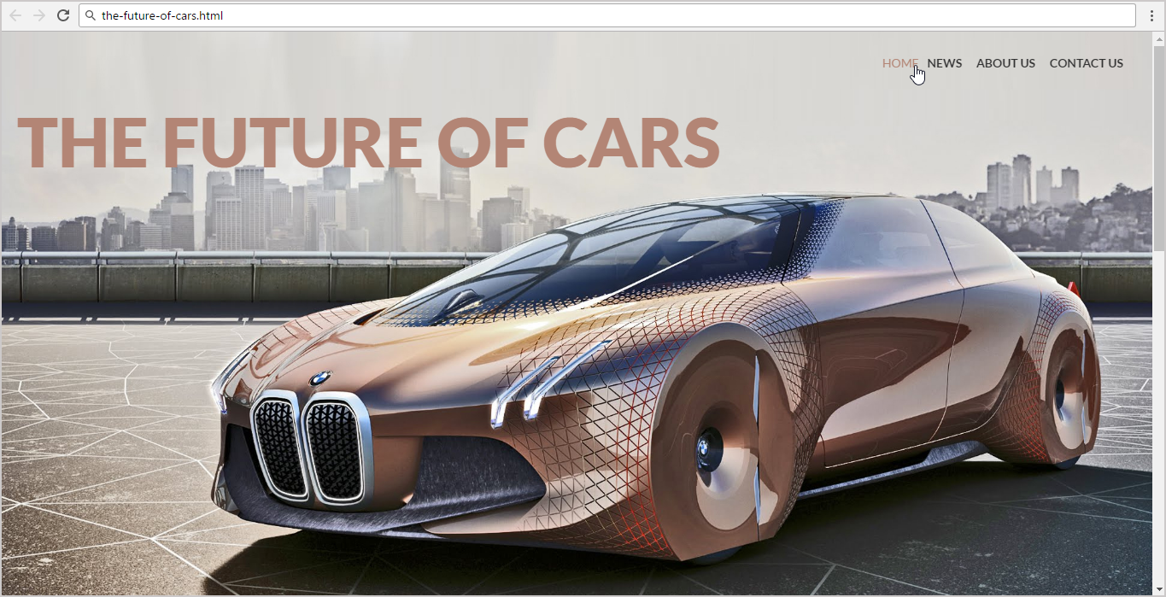

Now style the site content (articles):

* **Content section**
  + Padding Left: **25px;**
  + Padding Right: **25px;**
  + Align Text: **Justify;**
* **Articles in the content section**
  + Margin Bottom: **20px;**
* **Images in the articles**
  + Width: **350px;**
  + Height: **260px;**
  + Margin Right: **15px;**
  + Display the images on the left side (search in Google about “[CSS floating](https://www.google.com/search?q=CSS+floating)”)
* **Paragraphs in the articles**
  + Text Size: **18px;**
  + Text Color: **#333333;**
  + Margin: **0px;**
  + Padding: **20px;**
* **First letter in the first article’s paragraph**
  + Text Site: **32px;**
  + Text Color: **#b38575;**
  + Text Style: **bold;**
  + Make the text UPPERCASE
  + **Hint**: use the pseudo-selector :first-of-type:first-letter
* **Article heading <h2>**
  + Font Weight: **900**;
  + Text Color: **#b38575**
  + Margin-Bottom: **20px**;
  + Make the text uppercase

**Test** the site content (articles section) in the browser. Note that the articles will **overlap** like shown below:

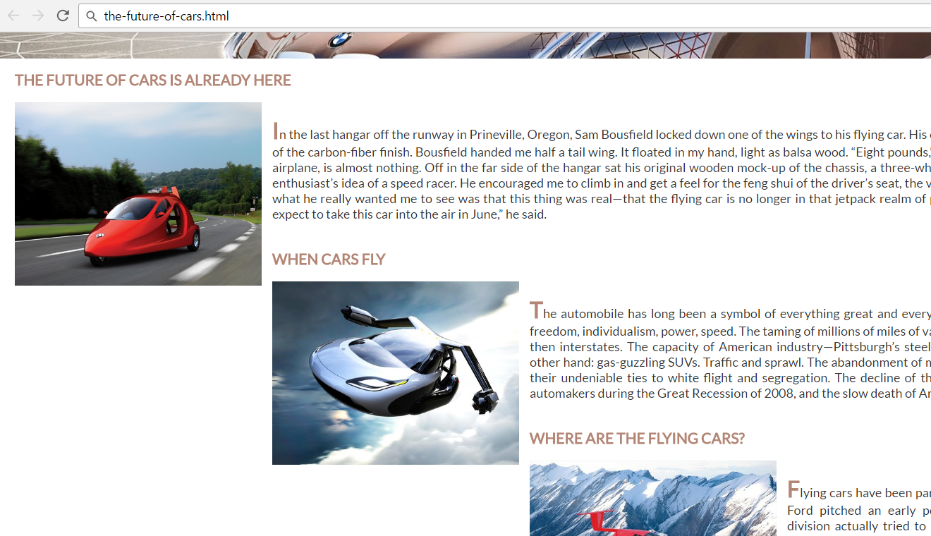

To **fix** the overlapping articles use a **“clearing” CSS** like this:

.content article:after **{**

content: '';

display: block**;**

clear: both;

**}**

Learn more about **floating and clearing** here**:** <https://css-tricks.com/all-about-floats/>.

**Test** the site content again. Now the articles should be displayed **correctly**:

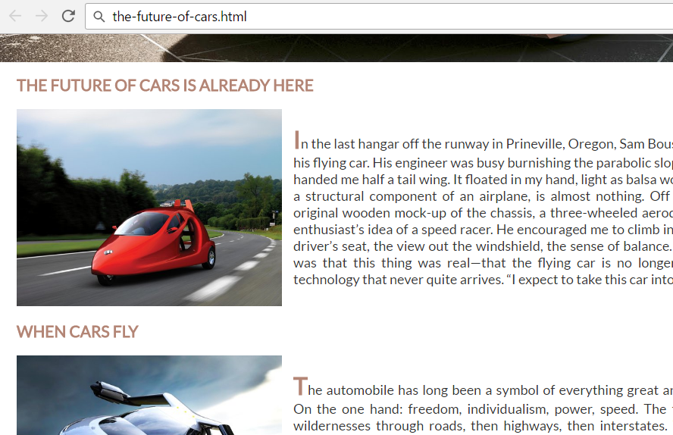

Now **style the site footer**:

* **<footer>**
  + Background Color: **#ccc;**
* **<span> in the footer**
  + Center the **<span>** content
  + Display as **block** element
  + Padding: **10px;**
  + Text Color: **#333333;**

**Test** the site in the Web browser again:

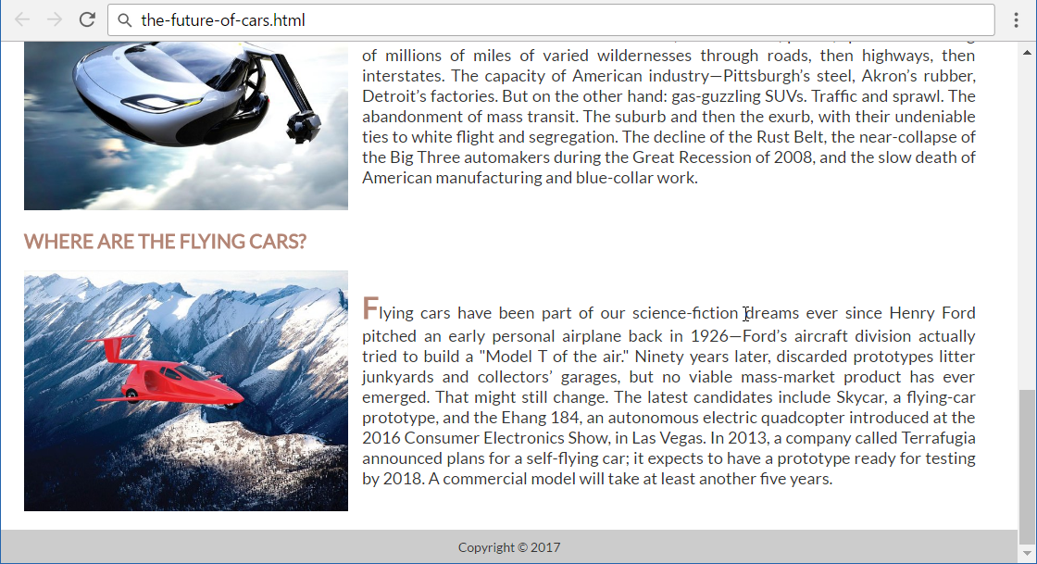

Now the site is styled completely. **Submit** your solution in the **SoftUni judge**:

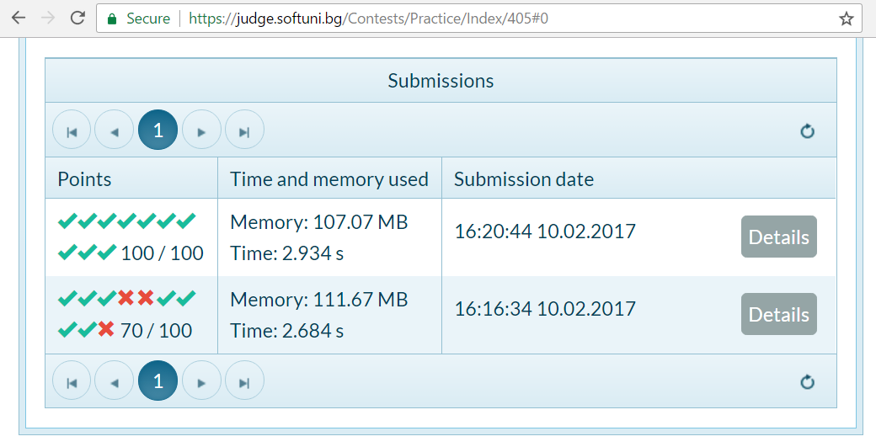

1. **Food Page**

Create a Web page like one below. Write the missing CSS.

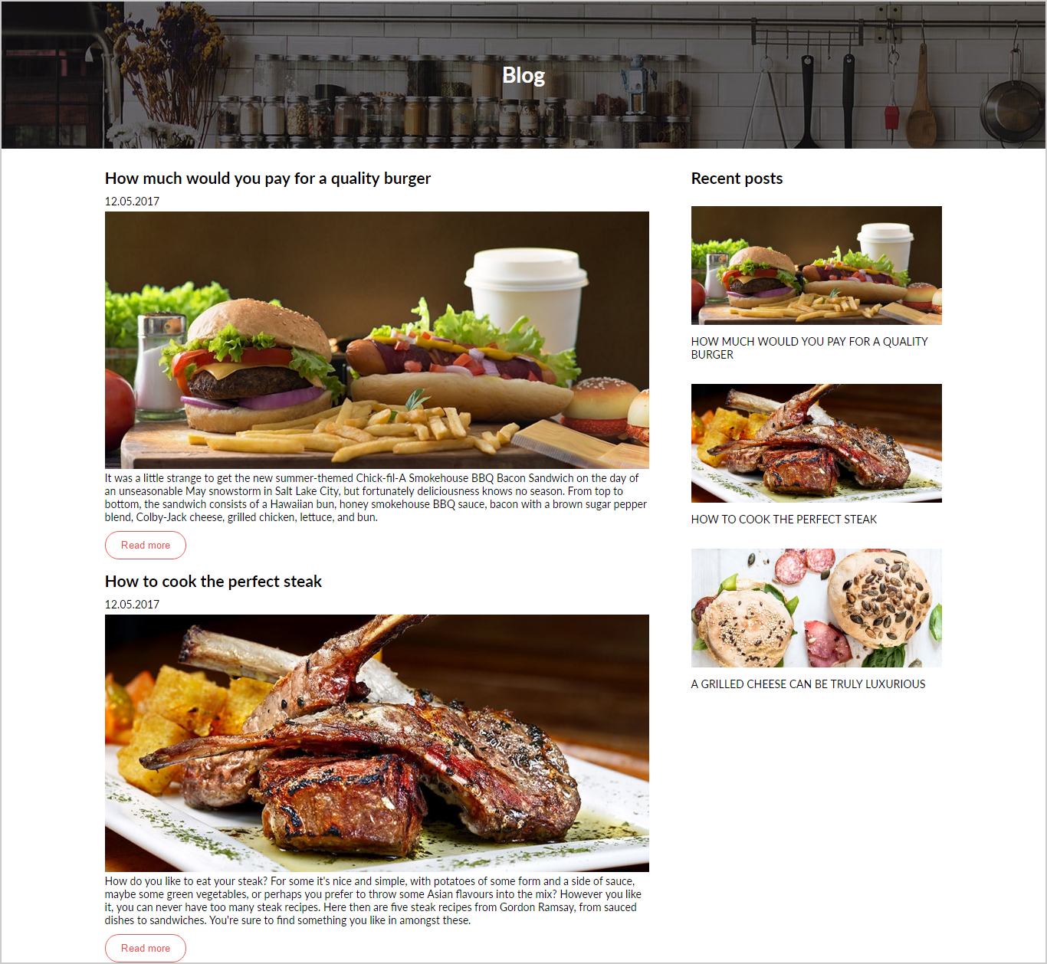

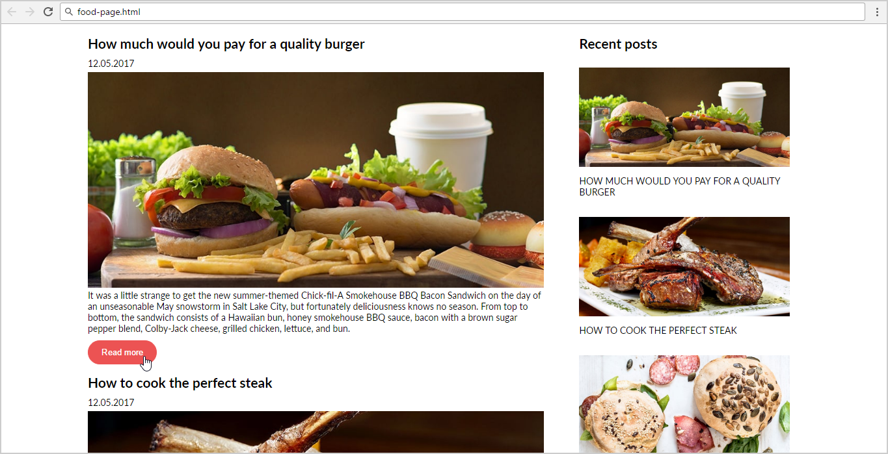

* Create the missing CSS file: "**food-blog.css**".
* You are **NOT** allowed to change the original HTML file.
* Default font: **Lato, sans-serif;**
* Colors: **#ec5353**, **#FFFFFF;**
* Default: **font-size: 14px;**

**Hints**

* Use **background: none** to remove <button> background.

## Japanese Kitchen

You are given the HTML for the Web page shown below. Write the missing CSS:

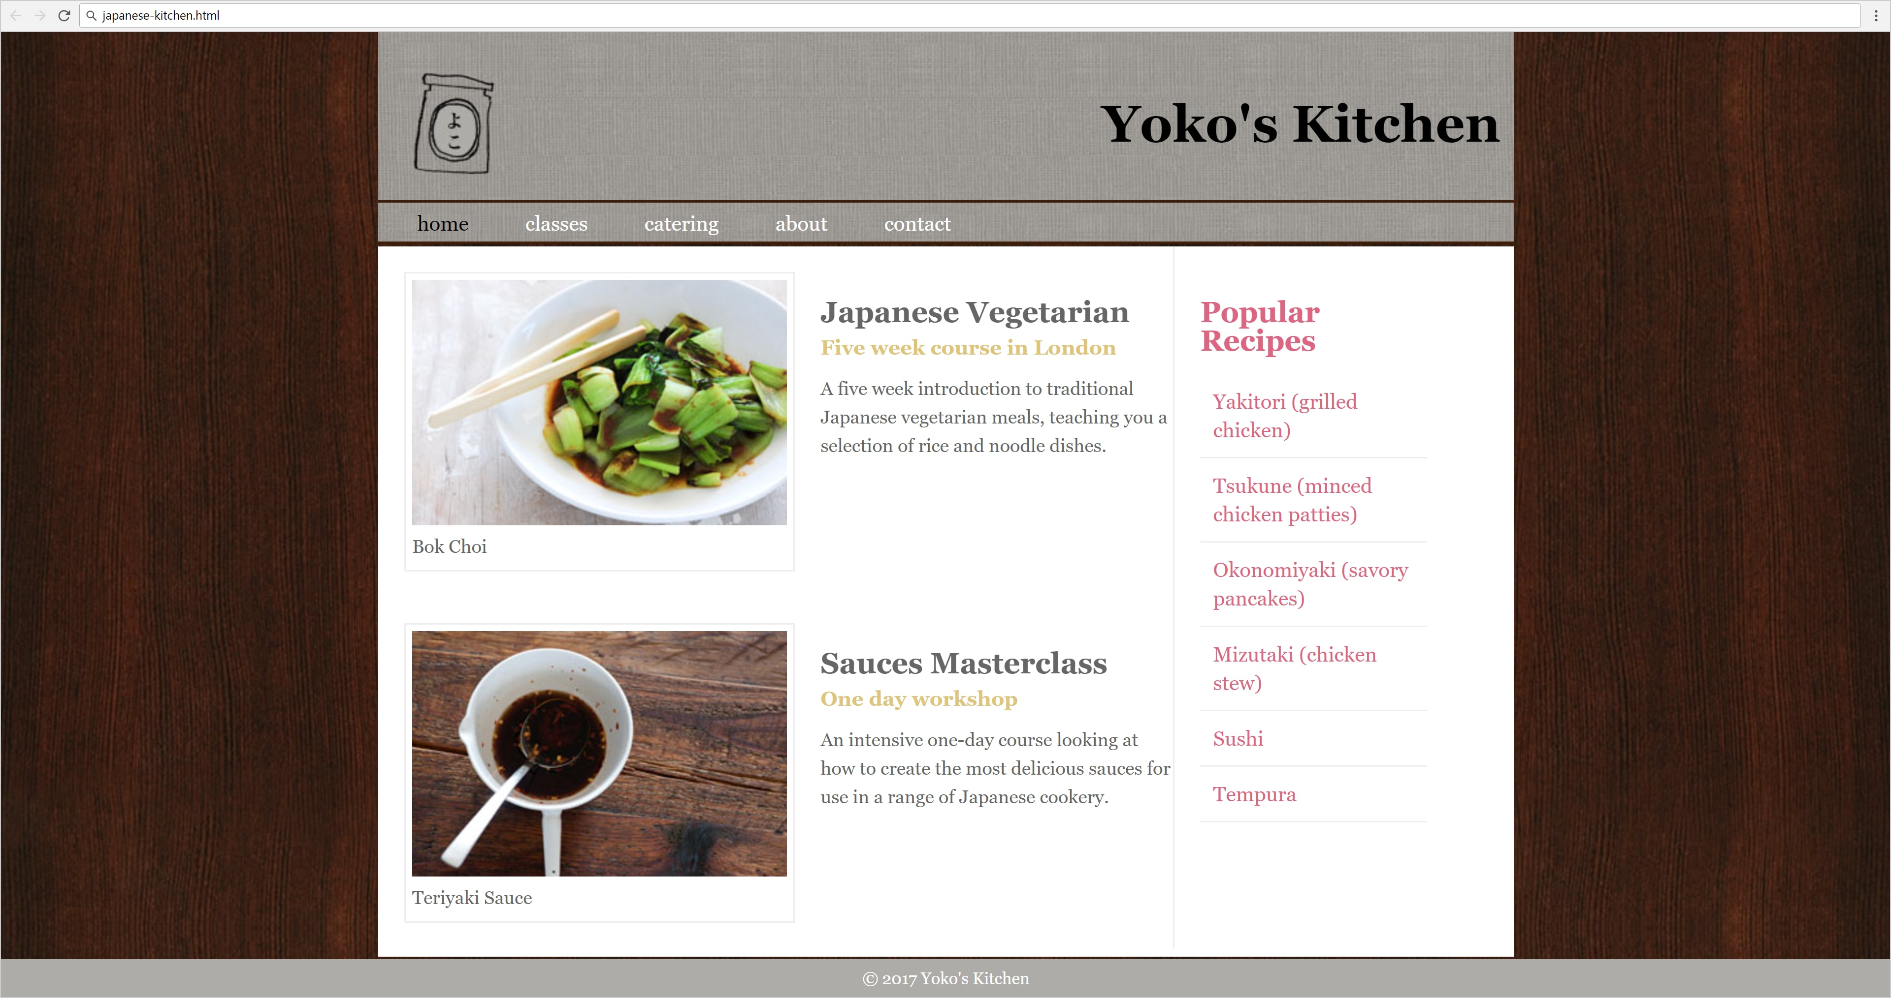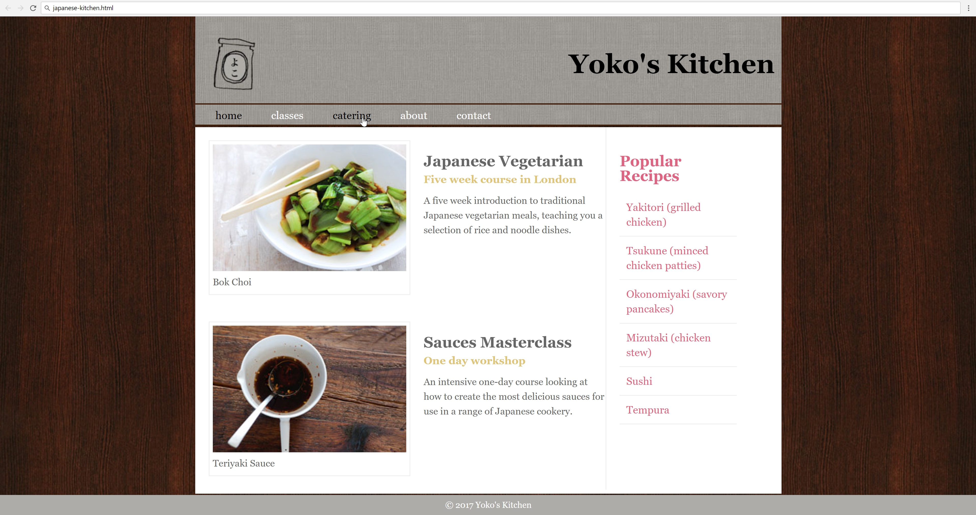

* Use the following HTML file: "japanese-kitchen.html".
  + You are **NOT** allowed to change the HTML code.
* Create the missing CSS file: "japanese-kitchen.css".

### Constraints

* **Reset** **CSS styles** at the start of your CSS.
* Default font: 14px 'Lato', sans-serif;